학과로 학생 조회하기

2019-11-26

이승진

**목차**

1. select 태그 #1 2

1) select1a.jsp 2

2) select1b.jsp 4

3) select1c.jsp 6

2. select 태그 #2 8

1) Department.java 8

2) DepartmentDAO.java 9

3) select1d.jsp 10

3. 학과로 학생 목록 조회 12

1) StudentDAO3.java 12

2) studentList4a.jsp 14

3) studentList4c.jsp 17

4) studentList4d.jsp 19

4. 실습 21

# select 태그 #1

## select1a.jsp

WebContent/form1/select1a.jsp

|  |  |
| --- | --- |
| 1  2  3  4  5  6  7  8  9  10  11  12  13  14  15  16  17  18  19  20  21  22  23  24  25  26  27  28  29  30  31  32  33  34  35  36  37  38 | <%@ page language="java" contentType="text/html; charset=UTF-8" pageEncoding="UTF-8"%>  <%@ page import="java.util.List, lecture1.jdbc1.*" %>  <%  String s = request.getParameter("departmentId");  %>  <!DOCTYPE html>  <html>  <head>  <meta http-equiv="Content-Type" content="text/html; charset=utf-8">  <meta name="viewport" content="width=device-width, initial-scale=1">  <link rel="stylesheet" href="https://maxcdn.bootstrapcdn.com/bootstrap/3.3.7/css/bootstrap.min.css">  <script src="https://ajax.googleapis.com/ajax/libs/jquery/3.1.1/jquery.min.js"></script>  <script src="https://maxcdn.bootstrapcdn.com/bootstrap/3.3.7/js/bootstrap.min.js"></script>  </head>  <body>  <div class="container">  <h1>select 태그</h1>  <form class="form-inline">  <div class="form-group">  <label>학과</label>  <select name="departmentId" class="form-control">  <option value="1">국어국문학</option>  <option value="2">영어영문학</option>  <option value="3">불어불문학</option>  </select>  </div>  <button type="submit" class="btn btn-primary">조회</button>  </form>  <hr />  departmentId: <%= s %>  </div>  </body>  </html> |

### 실행 과정 설명 #1

(1)

이클립스에서 select1a.jsp를 처음 실행할 때는,

서버에 전달되는 request parameter가 없다.

String s = request.getParameter("departmentId");

따라서 변수 s 에 null 값이 대입된다.

departmentId: <%= s %>

s 값 null 이 출력된다.

(2)

<select name="departmentId" class="form-control">

<option value="1">국어국문학</option>

<option value="2">영어영문학</option>

<option value="3">불어불문학</option>

</select>

특별히 지정하지 않으면, select 태그의 첫 째 option 태그가 선택된 상태로 출력된다.

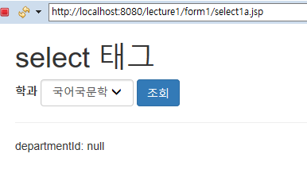

### 실행 과정 설명 #2

위 화면에서 '불어불문학'을 선택하고 조회 버튼을 클릭하면

서버에 요청되는 URL은 다음과 같다.

http://localhost:8080/lecture1/form1/select1a.jsp?**departmentId=3**

서버에 전달되는 request parameter에 다음 항목이 포함된다.

|  |  |
| --- | --- |
| request parameter name | value |
| departmentId | 3 |

String s = request.getParameter("departmentId");

따라서 변수 s 에 "3" 값이 대입된다.

departmentId: <%= s %>

s 값 "3" 이 출력된다. (문자열이 출력될 때, 따옴표는 출력되지 않는다.)

<select name="departmentId" class="form-control">

<option value="1">국어국문학</option>

<option value="2">영어영문학</option>

<option value="3">불어불문학</option>

</select>

특별히 지정하지 않으면, select 태그의 첫 째 option 태그가 선택된 상태로 출력된다.

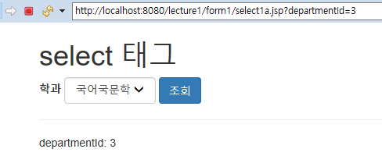

## select1b.jsp

WebContent/form1/select1b.jsp

|  |  |
| --- | --- |
| 1  2  3  4  5  6  7  8  9  10  11  12  13  14  15  16  17  18  19  20  21  22  23  24  25  26  27  28  29  30  31  32  33  34  35  36  37  38 | <%@ page language="java" contentType="text/html; charset=UTF-8" pageEncoding="UTF-8"%>  <%@ page import="java.util.List, lecture1.jdbc1.*" %>  <%  String s = request.getParameter("departmentId");  %>  <!DOCTYPE html>  <html>  <head>  <meta http-equiv="Content-Type" content="text/html; charset=utf-8">  <meta name="viewport" content="width=device-width, initial-scale=1">  <link rel="stylesheet" href="https://maxcdn.bootstrapcdn.com/bootstrap/3.3.7/css/bootstrap.min.css">  <script src="https://ajax.googleapis.com/ajax/libs/jquery/3.1.1/jquery.min.js"></script>  <script src="https://maxcdn.bootstrapcdn.com/bootstrap/3.3.7/js/bootstrap.min.js"></script>  </head>  <body>  <div class="container">  <h1>select 태그</h1>  <form class="form-inline">  <div class="form-group">  <label>학과</label>  <select name="departmentId" class="form-control">  <option value="1">국어국문학</option>  <option value="2">영어영문학</option>  <option value="3" selected>불어불문학</option>  </select>  </div>  <button type="submit" class="btn btn-primary">조회</button>  </form>  <hr />  departmentId: <%= s %>  </div>  </body>  </html> |

<select name="departmentId" class="form-control">

<option value="1">국어국문학</option>

<option value="2">영어영문학</option>

<option value="3" selected>불어불문학</option>

</select>

'불어불문학' 항목에 select 애트리뷰트를 지정했으므로,

언제나 '불어불문학' 항목이 선택된 상태로 출력된다.

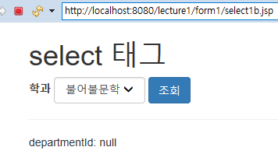

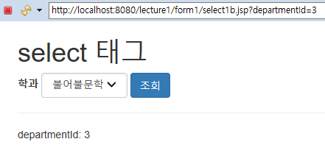

## select1c.jsp

WebContent/form1/select1b.jsp

|  |  |
| --- | --- |
| 1  2  3  4  5  6  7  8  9  10  11  12  13  14  15  16  17  18  19  20  21  22  23  24  25  26  27  28  29  30  31  32  33  34  35  36  37  38  39  40 | <%@ page language="java" contentType="text/html; charset=UTF-8" pageEncoding="UTF-8"%>  <%@ page import="java.util.List, lecture1.jdbc1.*" %>  <%  String s = request.getParameter("departmentId");  if (s == null) s = "1";  int departmentId = Integer.parseInt(s);  %>  <!DOCTYPE html>  <html>  <head>  <meta http-equiv="Content-Type" content="text/html; charset=utf-8">  <meta name="viewport" content="width=device-width, initial-scale=1">  <link rel="stylesheet" href="https://maxcdn.bootstrapcdn.com/bootstrap/3.3.7/css/bootstrap.min.css">  <script src="https://ajax.googleapis.com/ajax/libs/jquery/3.1.1/jquery.min.js"></script>  <script src="https://maxcdn.bootstrapcdn.com/bootstrap/3.3.7/js/bootstrap.min.js"></script>  </head>  <body>  <div class="container">  <h1>select 태그</h1>  <form class="form-inline">  <div class="form-group">  <label>학과</label>  <select name="departmentId" class="form-control">  <option value="1" <%= (departmentId == 1) ? "selected" : "" %> >국어국문학</option>  <option value="2" <%= (departmentId == 2) ? "selected" : "" %> >영어영문학</option>  <option value="3" <%= (departmentId == 3) ? "selected" : "" %> >불어불문학</option>  </select>  </div>  <button type="submit" class="btn btn-primary">조회</button>  </form>  <hr />  departmentId: <%= departmentId %>  </div>  </body>  </html> |

departmentId 값이 1 이면 위의 select 태그들은 다음과 같이 출력된다.

<select name="departmentId" class="form-control">

<option value="1" selected >국어국문학</option>

<option value="2" >영어영문학</option>

<option value="3" >불어불문학</option>

</select>

departmentId 값이 2 이면 위의 select 태그들은 다음과 같이 출력된다.

<select name="departmentId" class="form-control">

<option value="1" >국어국문학</option>

<option value="2" selected >영어영문학</option>

<option value="3" >불어불문학</option>

</select>

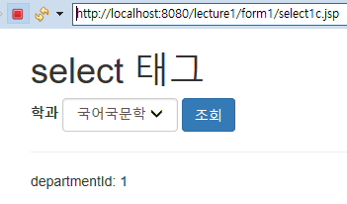

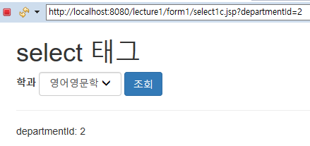

# select 태그 #2

학과 목록을 DB에서 조회해서 select 태그를 출력하자.

## Department.java

src/lecture1/jdbc1/Department.java

|  |  |
| --- | --- |
| 1  2  3  4  5  6  7  8  9  10  11  12  13  14  15  16  17  18  19  20  21  22 | package lecture1.jdbc1;  public class Department {  int id;  String departmentName;  public int getId() {  return id;  }  public void setId(int id) {  this.id = id;  }  public String getDepartmentName() {  return departmentName;  }  public void setDepartmentName(String departmentName) {  this.departmentName = departmentName;  }  } |

department 테이블에서 조회한 데이터를 채워서 전달하기 위한 DTO 객체 (Data Transfer Object)

## DepartmentDAO.java

src/lecture1/jdbc1/DepartmentDAO.java

|  |  |
| --- | --- |
| 1  2  3  4  5  6  7  8  9  10  11  12  13  14  15  16  17  18  19  20  21  22  23  24  25  26  27  28 | package lecture1.jdbc1;  import java.sql.Connection;  import java.sql.PreparedStatement;  import java.sql.ResultSet;  import java.util.ArrayList;  import java.util.List;  import lecture1.DB;  public class DepartmentDAO {  public static List<Department> findAll() throws Exception {  String sql = "SELECT * FROM department";  try (Connection connection = DB.getConnection("student1");  PreparedStatement statement = connection.prepareStatement(sql);  ResultSet resultSet = statement.executeQuery()) {  ArrayList<Department> list = new ArrayList<Department>();  while (resultSet.next()) {  Department department = new Department();  department.setId(resultSet.getInt("id"));  department.setDepartmentName(resultSet.getString("departmentName"));  list.add(department);  }  return list;  }  }  } |

department 테이블에서 학과 레코드 전체를 조회해서 리턴하는 메소드를 구현함.

## select1d.jsp

WebContent/form1/select1b.jsp

|  |  |
| --- | --- |
| 1  2  3  4  5  6  7  8  9  10  11  12  13  14  15  16  17  18  19  20  21  22  23  24  25  26  27  28  29  30  31  32  33  34  35  36  37  38  39  40  41  42  43  44  45  46 | <%@ page language="java" contentType="text/html; charset=UTF-8" pageEncoding="UTF-8"%>  <%@ page import="java.util.List, lecture1.jdbc1.*" %>  <%  String s = request.getParameter("departmentId");  if (s == null) s = "1";  int departmentId = Integer.parseInt(s);  List<Department> departments = DepartmentDAO.findAll();  %>  <!DOCTYPE html>  <html>  <head>  <meta http-equiv="Content-Type" content="text/html; charset=utf-8">  <meta name="viewport" content="width=device-width, initial-scale=1">  <link rel="stylesheet" href="https://maxcdn.bootstrapcdn.com/bootstrap/3.3.7/css/bootstrap.min.css">  <script src="https://ajax.googleapis.com/ajax/libs/jquery/3.1.1/jquery.min.js"></script>  <script src="https://maxcdn.bootstrapcdn.com/bootstrap/3.3.7/js/bootstrap.min.js"></script>  </head>  <body>  <div class="container">  <h1>select 태그</h1>  <form class="form-inline">  <div class="form-group">  <label>학과</label>  <select name="departmentId" class="form-control">  <% for (Department department : departments) { %>  <% int id = department.getId(); %>  <% String name = department.getDepartmentName(); %>  <option value="<%= id %>" <%= (departmentId == id) ? "selected" : "" %> >  <%= name %>  </option>  <% } %>  </select>  </div>  <button type="submit" class="btn btn-primary">조회</button>  </form>  <hr />  departmentId: <%= departmentId %>  </div>  </body>  </html> |

List<Department> departments = DepartmentDAO.findAll();

department 테이블에서 학과 레코드 전체를 조회한다.

departments 변수에 학과 목록 객체가 대입된다.

<% for (Department department : departments) { %>

departments 학과 목록 내부의 학과(Department)객체 각각에 대해서,

아래 내용을 반복 출력한다.

<% int id = department.getId(); %>

현재 Department 객체의 id 값을, 지역 변수 id 에 대입한다.

<% String name = department.getDepartmentName(); %>

현재 Department 객체의 이름(departmentName) 값을, 지역 변수 name 에 대입한다.

<option value="<%= id %>" <%= (departmentId == id) ? "selected" : "" %> >

예를 들어 id 변수 값이 3 이고, departmentId 값이 3 이면, 위 option 태그는 다음과 같이 출력된다.

<option value="3" selected > 문자열이 출력될 때, 따옴표는 출력되지 않음에 주목하자.

예를 들어 id 변수 값이 3 이고, departmentId 값이 2 이면, 위 option 태그는 다음과 같이 출력된다.

<option value="3" > 문자열이 출력될 때, 따옴표는 출력되지 않음에 주목하자.

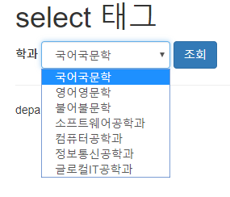

# 학과로 학생 목록 조회

## StudentDAO3.java

src/lecture1/jdbc1/StudentDAO3.java

|  |  |
| --- | --- |
| 1  2  3  4  5  6  7  8  9  10  11  12  13  14  15  16  17  18  19  20  21  22  23  24  25  26  27  28  29  30  31  32  33  34  35  36  37  38  39  40  41  42  43  44  45  46  47  48  49  50  51  52  53  54  55  56  57  58  59  60  61  62  63  64  65  66  67  68  69  70  71  72  73  74  75  76  77  78  79  80  81  82  83  84  85 | package lecture1.jdbc1;  import java.sql.Connection;  import java.sql.PreparedStatement;  import java.sql.ResultSet;  import java.sql.SQLException;  import java.util.ArrayList;  import java.util.List;  import lecture1.DB;  public class StudentDAO3 {  private static Student getStudentFrom(ResultSet resultSet) throws SQLException {  Student student = new Student();  student.setId(resultSet.getInt("id"));  student.setStudentNumber(resultSet.getString("studentNumber"));  student.setName(resultSet.getString("name"));  student.setDepartmentId(resultSet.getInt("departmentId"));  student.setYear(resultSet.getInt("year"));  student.setDepartmentName(resultSet.getString("departmentName"));  return student;  }  public static List<Student> findAll() throws Exception {  String sql = "SELECT s.*, d.departmentName " +  "FROM student s LEFT JOIN department d ON s.departmentId = d.id";  try (Connection connection = DB.getConnection("student1");  PreparedStatement statement = connection.prepareStatement(sql);  ResultSet resultSet = statement.executeQuery()) {  ArrayList<Student> list = new ArrayList<Student>();  while (resultSet.next())  list.add(getStudentFrom(resultSet));  return list;  }  }  public static List<Student> findByName(String name) throws Exception {  String sql = "SELECT s.*, d.departmentName " +  "FROM student s LEFT JOIN department d ON s.departmentId = d.id " +  "WHERE s.name LIKE ?";  try (Connection connection = DB.getConnection("student1");  PreparedStatement statement = connection.prepareStatement(sql)) {  statement.setString(1, name + "%");  try (ResultSet resultSet = statement.executeQuery()) {  ArrayList<Student> list = new ArrayList<Student>();  while (resultSet.next())  list.add(getStudentFrom(resultSet));  return list;  }  }  }  public static Student findById(int id) throws Exception {  String sql = "SELECT s.*, d.departmentName " +  "FROM student s LEFT JOIN department d ON s.departmentId = d.id " +  "WHERE s.id = ?";  try (Connection connection = DB.getConnection("student1");  PreparedStatement statement = connection.prepareStatement(sql)) {  statement.setInt(1, id);  try (ResultSet resultSet = statement.executeQuery()) {  if (resultSet.next())  return getStudentFrom(resultSet);  else  return null;  }  }  }  public static List<Student> findByDepartmentId(int departmentId) throws Exception {  String sql = "SELECT s.*, d.departmentName " +  "FROM student s LEFT JOIN department d ON s.departmentId = d.id " +  "WHERE s.departmentId = ?";  try (Connection connection = DB.getConnection("student1");  PreparedStatement statement = connection.prepareStatement(sql)) {  statement.setInt(1, departmentId);  try (ResultSet resultSet = statement.executeQuery()) {  ArrayList<Student> list = new ArrayList<Student>();  while (resultSet.next())  list.add(getStudentFrom(resultSet));  return list;  }  }  }  } |

public static List<Student> findByDepartmentId(int departmentId)

학과ID(departmentId)로 학생 목록을 조회하는 메소드 구현

## studentList4a.jsp

WebContent/jdbc1/studentList4a.jsp

|  |  |
| --- | --- |
| 1  2  3  4  5  6  7  8  9  10  11  12  13  14  15  16  17  18  19  20  21  22  23  24  25  26  27  28  29  30  31  32  33  34  35  36  37  38  39  40  41  42  43  44  45  46  47  48  49  50  51  52  53  54  55  56  57  58  59  60  61  62  63 | <%@ page language="java" contentType="text/html; charset=UTF-8" pageEncoding="UTF-8"%>  <%@ page import="java.util.List, lecture1.jdbc1.*" %>  <%  String s = request.getParameter("departmentId");  if (s == null) s = "1";  int departmentId = Integer.parseInt(s);  List<Student> students = StudentDAO3.findByDepartmentId(departmentId);  %>  <!DOCTYPE html>  <html>  <head>  <meta http-equiv="Content-Type" content="text/html; charset=utf-8">  <meta name="viewport" content="width=device-width, initial-scale=1">  <link rel="stylesheet" href="https://maxcdn.bootstrapcdn.com/bootstrap/3.3.7/css/bootstrap.min.css">  <script src="https://ajax.googleapis.com/ajax/libs/jquery/3.1.1/jquery.min.js"></script>  <script src="https://maxcdn.bootstrapcdn.com/bootstrap/3.3.7/js/bootstrap.min.js"></script>  <style>  thead th { background-color: #eee; }  table.table { width: 700px; margin-top: 10px; }  </style>  </head>  <body>  <div class="container">  <h1>학생목록</h1>  <form class="form-inline">  <div class="form-group">  <label>학과</label>  <select name="departmentId" class="form-control">  <option value="1">국어국문학</option>  <option value="2">영어영문학</option>  <option value="3">불어불문학</option>  </select>  </div>  <button type="submit" class="btn btn-primary">조회</button>  </form>  <table class="table table-bordered table-condensed">  <thead>  <tr>  <th>학번</th>  <th>이름</th>  <th>학과</th>  <th>학년</th>  </tr>  </thead>  <tbody>  <% for (Student student : students) { %>  <tr>  <td><%= student.getStudentNumber() %></td>  <td><a href="student2.jsp?id=<%= student.getId() %>"><%= student.getName() %></a></td>  <td><%= student.getDepartmentName() %></td>  <td><%= student.getYear() %></td>  </tr>  <% } %>  </tbody>  </table>  </div>  </body>  </html> |

### 실행 과정 설명 #1

String s = request.getParameter("departmentId");

이클립스에서 studentList4a.jsp 를 처음 실행할 때,

서버에 전달되는 request parameter 는 없으므로,

지역 변수 s 에 null 값이 대입된다.

if (s == null) s = "1";

따라서 지역 변수 s 에 "1" 문자열이 대입된다.

int departmentId = Integer.parseInt(s);

departmentId 지역 변수에 int 값 1 이 대입된다.

List<Student> students = StudentDAO3.findByDepartmentId(departmentId);

departmentId 값 1 로 학생 목록을 조회하여

Student 객체 목록을, 지역 변수 students 에 대입한다.

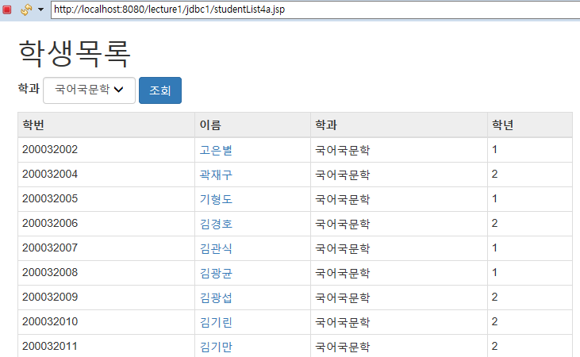

### 실행 과정 설명 #2

위 화면에서 '영어영문학' 학과를 선택하고 조회 버튼을 클릭하자.

이때 서버에 요청되는 URL은 다음과 같다.

http://localhost:8080/lecture1/jdbc1/studentList4a.jsp?departmentId=2

String s = request.getParameter("departmentId");

지역 변수 s 에 "2" 문자열이 대입된다.

int departmentId = Integer.parseInt(s);

departmentId 지역 변수에 int 값 2 가 대입된다.

List<Student> students = StudentDAO3.findByDepartmentId(departmentId);

departmentId 값 2 로 학생 목록을 조회하여

Student 객체 목록을, 지역 변수 students 에 대입한다.

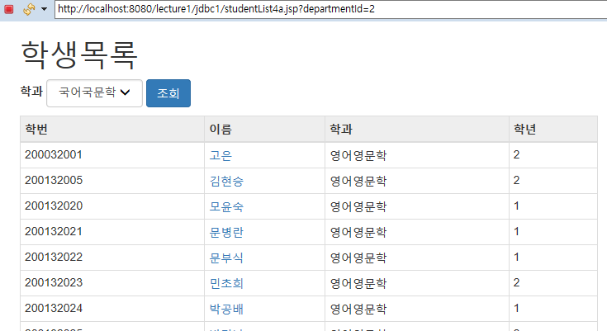

위 화면에서 '국어국문학' 학과가 선택되어 있음에 주목하자.

그리고 조회된 학생들은 '영어영문학' 학과 학생들임에 주목하자.

select 태그에 특별한 지정이 없다면,

언제나 첫 번째 option 태그가 선택된 상태로 출력된다.

## studentList4c.jsp

WebContent/jdbc1/studentList4c.jsp

|  |  |
| --- | --- |
| 1  2  3  4  5  6  7  8  9  10  11  12  13  14  15  16  17  18  19  20  21  22  23  24  25  26  27  28  29  30  31  32  33  34  35  36  37  38  39  40  41  42  43  44  45  46  47  48  49  50  51  52  53  54  55  56  57  58  59  60  61  62  63 | <%@ page language="java" contentType="text/html; charset=UTF-8" pageEncoding="UTF-8"%>  <%@ page import="java.util.List, lecture1.jdbc1.*" %>  <%  String s = request.getParameter("departmentId");  if (s == null) s = "1";  int departmentId = Integer.parseInt(s);  List<Student> students = StudentDAO3.findByDepartmentId(departmentId);  %>  <!DOCTYPE html>  <html>  <head>  <meta http-equiv="Content-Type" content="text/html; charset=utf-8">  <meta name="viewport" content="width=device-width, initial-scale=1">  <link rel="stylesheet" href="https://maxcdn.bootstrapcdn.com/bootstrap/3.3.7/css/bootstrap.min.css">  <script src="https://ajax.googleapis.com/ajax/libs/jquery/3.1.1/jquery.min.js"></script>  <script src="https://maxcdn.bootstrapcdn.com/bootstrap/3.3.7/js/bootstrap.min.js"></script>  <style>  thead th { background-color: #eee; }  table.table { width: 700px; margin-top: 10px; }  </style>  </head>  <body>  <div class="container">  <h1>학생목록</h1>  <form class="form-inline">  <div class="form-group">  <label>학과</label>  <select name="departmentId" class="form-control">  <option value="1" <%= (departmentId == 1) ? "selected" : "" %> >국어국문학</option>  <option value="2" <%= (departmentId == 2) ? "selected" : "" %> >영어영문학</option>  <option value="3" <%= (departmentId == 3) ? "selected" : "" %> >불어불문학</option>  </select>  </div>  <button type="submit" class="btn btn-primary">조회</button>  </form>  <table class="table table-bordered table-condensed">  <thead>  <tr>  <th>학번</th>  <th>이름</th>  <th>학과</th>  <th>학년</th>  </tr>  </thead>  <tbody>  <% for (Student student : students) { %>  <tr>  <td><%= student.getStudentNumber() %></td>  <td><a href="student2.jsp?id=<%= student.getId() %>"><%= student.getName() %></a></td>  <td><%= student.getDepartmentName() %></td>  <td><%= student.getYear() %></td>  </tr>  <% } %>  </tbody>  </table>  </div>  </body>  </html> |

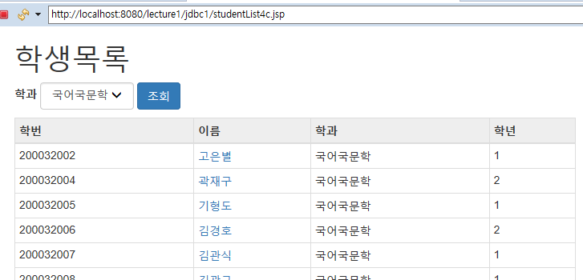

처음 실행한 화면

위 화면에서 영어영문학과를 선택하고 조회 버튼을 클릭하자.

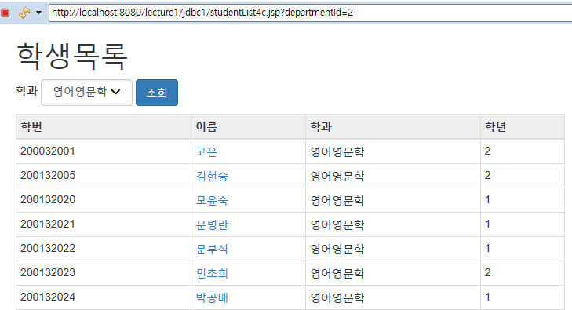

## studentList4d.jsp

WebContent/jdbc1/studentList4d.jsp

|  |  |
| --- | --- |
| 1  2  3  4  5  6  7  8  9  10  11  12  13  14  15  16  17  18  19  20  21  22  23  24  25  26  27  28  29  30  31  32  33  34  35  36  37  38  39  40  41  42  43  44  45  46  47  48  49  50  51  52  53  54  55  56  57  58  59  60  61  62  63  64  65  66  67  68  69 | <%@ page language="java" contentType="text/html; charset=UTF-8" pageEncoding="UTF-8"%>  <%@ page import="java.util.List, lecture1.jdbc1.*" %>  <%  String s = request.getParameter("departmentId");  if (s == null) s = "1";  int departmentId = Integer.parseInt(s);  List<Student> students = StudentDAO3.findByDepartmentId(departmentId);  List<Department> departments = DepartmentDAO.findAll();  %>  <!DOCTYPE html>  <html>  <head>  <meta http-equiv="Content-Type" content="text/html; charset=utf-8">  <meta name="viewport" content="width=device-width, initial-scale=1">  <link rel="stylesheet" href="https://maxcdn.bootstrapcdn.com/bootstrap/3.3.7/css/bootstrap.min.css">  <script src="https://ajax.googleapis.com/ajax/libs/jquery/3.1.1/jquery.min.js"></script>  <script src="https://maxcdn.bootstrapcdn.com/bootstrap/3.3.7/js/bootstrap.min.js"></script>  <style>  thead th { background-color: #eee; }  table.table { width: 700px; margin-top: 10px; }  </style>  </head>  <body>  <div class="container">  <h1>학생목록</h1>  <form class="form-inline">  <div class="form-group">  <label>학과</label>  <select name="departmentId" class="form-control">  <% for (Department department : departments) { %>  <% int id = department.getId(); %>  <% String name = department.getDepartmentName(); %>  <option value="<%= id %>" <%= (departmentId == id) ? "selected" : "" %> >  <%= name %>  </option>  <% } %>  </select>  </div>  <button type="submit" class="btn btn-primary">조회</button>  </form>  <table class="table table-bordered table-condensed">  <thead>  <tr>  <th>학번</th>  <th>이름</th>  <th>학과</th>  <th>학년</th>  </tr>  </thead>  <tbody>  <% for (Student student : students) { %>  <tr>  <td><%= student.getStudentNumber() %></td>  <td><a href="student2.jsp?id=<%= student.getId() %>"><%= student.getName() %></a></td>  <td><%= student.getDepartmentName() %></td>  <td><%= student.getYear() %></td>  </tr>  <% } %>  </tbody>  </table>  </div>  </body>  </html> |

List<Department> departments = DepartmentDAO.findAll();

DB 에서 학과 목록 전체를 조회하여,

Department 객체 목록을, 지역 변수 departments 에 대입한다.

# 실습

학과 목록으로 사용자 목록을 조회하는 JSP 페이지를 구현하시오.